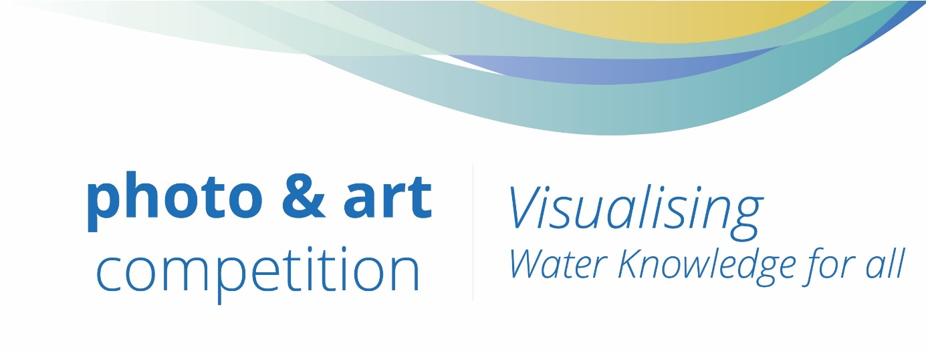
Cap-Net is UNDP´s global network to enhance individual and institutional knowledge and capacities at local, national and regional levels, along with South-South collaboration for sustainable water management.

Our vision is ’Water knowledge for all’. In light of making our vision a reality, we have just launched our newly revamped website and Virtual Campus that provide an enhanced learning experience.

We would like to celebrate such an important milestone in Cap-Net’s journey with the water community through this photo and art competition. We ask contestants to send us photos and/or artwork that answer the question: How do you visualise ‘water knowledge for all’? All of the submissions should be linked to any of our five topics: Water Governance, Ecosystems, Climate Change, Gender, Innovative Solutions

You are invited to submit up to three artworks or photos that reflect on any of the five topics. Each submission should be accompanied with a short description answering the proposed question.

Winners will be announced virtually at the end of May 2020.
Do you want to participate? Submit the images in our website and send the signed ‘Grant of rights‘ form to communicationsteam@cap-net.org, by 23.59 CET Friday 1 May 2020.

You will not be able to submit your work if you do not send the signed form.

The Prize

The best artworks and/or photo will be awarded:

- First place: Amazon Gift Card 100 USD
- Second place: Amazon Gift Card 50 USD

Best two photos will have exposure in Cap-Net Network Managers Meeting and at any other conference that Cap-Net attends and has presence during 2020.

How it works

- Fill out the Grant of rights – Terms and Conditions and send them to communicationsteam@cap-net.org
- Submit your artwork and/or pictures to shortstack.com/Cap-Net

You are in the run! Now, invite your network to vote!

Submission criteria

All submissions must comply with the following criteria otherwise they will be discarded:
- The participant must send the ‘Grant of rights‘ form signed to
communicationsteam@cap-net.org
- Submissions must be related to any of the five Cap-Net topics: Water Governance, Climate Change, Ecosystems, Innovative Solutions, Gender.
- A maximum of three items (artwork/s and/or photo/s) can be submitted in JPEG/JPG or PNG in high resolution.
- A short description for each of the submissions as companion of the artwork and/or photo must be added.
- Compliance of EU GDPR must be followed. Images should not portray any personal information without consent of the involved parties in the artwork/photo.

The jury: People’s award choice

Cap-Net team bases its work and conducts on the following core values as an organisation within GWP and UNDP network: Integrity, Transparency, Accountability, Collaboration, Commitment, Inclusiveness, Openness, Respect, Gender sensitivity and Solidarity. In spirit of our values, the jury of this contest will be the people voting through the Shortstack app.

Encourage your network to visit Cap-Net website and social media and vote for your artwork!

Grant of rights – Terms and Conditions

- By submitting the artwork and/or photos to the Cap-Net photo and art competition, the participant grants the rights and permission to Cap-Net UNDP - International Capacity Development Network for Sustainable Water Management -hosted by the Global Water Partnership Organisation to:
- Use and replicate artwork and/or photos without limitation on the number of reproductions, impressions, space, language, amount of copies and/or use and time;
- Use and replicate artwork and/or photos at any time for any non-commercial uses;
- Use and replicate artwork and/or photos in any way of media, format and channels including but not limited to: websites, media in general, reports, books, publications, posters, flyers, social media, mobile advertisement, electronic publications, portable drive devices, mobile applications, banners used at any venue, conference or seminar, or by other materials and media of any nature, on the condition that the artwork and/or photos are credited to their creator (the participant).

- By submitting the artwork and/or photos to the Cap-Net photo and art competition, the participant acknowledges and certifies that:
- He/She is the sole copyright-holder of the artwork and/or photo and has full power to sign the terms and conditions and to authorize the use of the artwork and/or photo as set in paragraph 1.
- The artwork and/or photo is original to the participant.
- The artwork and/or photo is in no way a violation of any existing copyright or any other right granted to any other institution or individual and contains nothing otherwise unlawful.

- By submitting the artwork and/or photos to the Cap-Net photo and art competition, the participant accepts:
- privately, personally and exclusively, all civil/criminal liability related to the animals, items and/or people portrayed in their artwork and/or photos and releases those liabilities from Cap-Net UNDP - International Capacity Development Network for Sustainable Water Management -hosted by the Global Water Partnership Organisation, and its institutional partners.

- All participants – winners and non-winners- accept and authorise Cap-Net UNDP to use their artwork and/or photos and name with the conditions set in paragraph 1.

General public is encouraged to apply. Cap-Net, UNDP, GWPO staff and members, or their relatives, may not apply.
Cap-Net affiliated networks, GWP Regional Water Partnerships and Country Water Partnerships, and institutional partners may apply.

The name of my artwork/s and/ or photo/s:
- __________________________________
- __________________________________
- __________________________________

As of ______________________ (date), I (“The participant”)____________________________________________ (full name) hereby acknowledge and accept all the terms and conditions.

