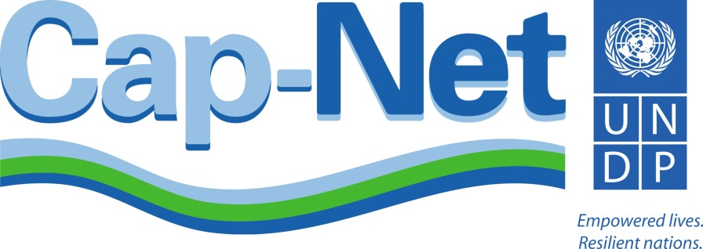

International Network for Capacity Development
in Sustainable Water Management

Sustainable Networks
Financing, activities and managing risks

Cap-Net Network Managers and Partners Meeting, 10-14 November 2014, Victoria Falls, Zimbabwe

Monday 10 November: Partners’ meeting

Time | Subject | Facilitator
Morning 9:00 | Opening | Jean Marie, Themba
 | Effective partnerships for capacity development in sustainable water management  - Outcomes of network attachment’s study on partnership development | Themba
 | Coffee break
 | Discussion on what works and what to improve | Kees
13:00 – 14:00 | Lunch
14:00 – 14:10 | Ice breaker/ Exercise
Afternoon | Partners’ platform:  - introducing new partnerships and invitations to collaborate | Partners
 | Tea break
 | Expectations and contributions by the partners – discussion | Partners
 | Engaging new donors and partners | Themba
 | World Water Day and annual campaign 2015 on Water and Sustainable Development | Joakim + Kees

Tuesday 11 November: Interaction Partners and Networks

Time | Subject | Facilitator
Morning 9:00 | Partners and networks market place | Kees
10:45 – 11:00 | Coffee Break
 | Partners and networks market place
13:00 – 14:00 | Lunch
Afternoon | Field Visit (informal)* | Jean Marie

Wednesday 12 November: Network managers meeting

Time | Subject | Facilitator
Morning 9:00 | Opening | Themba
 | Update on the Cap-Net strategic document
 | Report on external evaluation | Joakim
10:45 – 11:00 | Coffee break
 | Exchange on Experiences and Lessons Learned in 2014 | Neena
 | Introduction to the programme | Kees
 | Concept and distribution of working groups
 | Discussions
13:00 – 14:00 | Lunch
14:00 – 14:10 | Ice breaker/ Exercise
 | Networks’ annual work plans | Callist
 | Working group discussions
Afternoon | Tea break
 | Outcomes of the Leverage Effect Report | Yasmina
 | Discussion
 | Working group discussions

Thursday 13 November

Time | Subject | Facilitator
Morning 9:00 | Update on SDGs and post-2015 negotiations, and implications for Cap-Net | Joakim
 | Working group discussions
10:45 – 11:00 | Coffee break
 | Update on development of the virtual campus | Damian
 | Working group discussions
13:00 – 14:00 | Lunch
14:00 – 14:10 | Ice breaker/Exercise
Afternoon | Working group discussions
 | Tea break
 | Contracting and travel modalities, pitfalls and what to watch out for vis-à-vis UNOPS procedures | Sonia
 | Reporting templates (technical, financial) | Ivan
 | Outcomes of the MELP training: what did we learn? MELP Reporting template | Indika

Friday 14 November

Time | Subject | Facilitator
Morning 9:00 | Working group discussions
10:45 – 11:00 | Coffee break
 | Reporting back by working groups | Kees
 | Discussions
13:00 – 14:00 | Lunch
Afternoon | Priorities in 2015 and conclusions for Cap-Net work plan | Themba
 | Recap of the meeting | Wangai
 | Tea break
15.00 – 15.30 | Election representatives and closure | Jean Marie, Themba
16.00 | Sun-downer cruise and closing dinner | Jean Marie

Working groups:

Develop strategies on
- Financing, finance issues and support
- Programme identification and development, working with partners
- Network management issues; tools to be developed, how to mobilise less active networks
- Delivery of capacity development – how to encourage members to develop and deliver, conditions for support; monitoring and evaluation (MELP)
- Managing risks, fund raising and engaging new donors
The working groups will be presented with ToRs with series of questions and are expected to report back on Friday with strategies on the various subjects. A reporting template will be presented. Outcomes ready to be incorporated in Cap-Net’s strategy. Cap-Net Secretariat will take note of the minutes of the meetings on a daily basis, and share them accordingly.

*Field Visit (informal) – this will be a visit to the falls and bridge and can be combined with bungee jumping activities, flight of angels, gave viewing etc bookings can be made individually check http://www.victoriafalls-guide.net/. More details will be provided on site.

