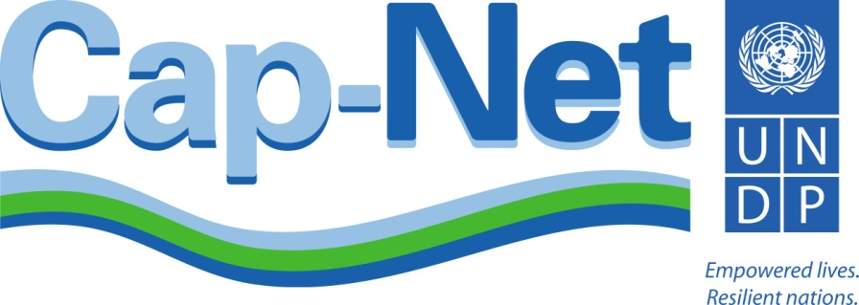

International Network for Capacity Development
in Sustainable Water Management

Contribution to the implementation of Sustainable Development Goals
2016-2020

“Water Knowledge for All”
“Empowering Individuals: Enabling Environments”

September 2015

Contents

Preamble 3
Cap-Net UNDP poised for action 4
The Post-2015 development Agenda 5
Cap-Net UNDP contribution to the new development Agenda 5
Means of implementation in achieving SDGs 9
SDGs and targets addressed by Cap-Net 12
Financial envelope 13

Preamble

The world today confronts a water crisis with critical implications for peace, political stability and economic development. Starting to manage water resources more effectively and efficiently will enable humanity to better respond to today’s problems and to the surprises and troubles expected in a warming world. Water flows through the three pillars of sustainable development: economic, social and environmental. It is inextricably linked to climate change, agriculture, food security and is essential for achieving many of the future development targets.

The sustainable management of water resources is becoming more urgent than ever as several global trends collide. In developing countries, growing populations are increasing demand for water to produce essential commodities like food and energy. Higher rates of urbanisation fuel demand for water for domestic and industrial uses, putting stress on existing raw water sources.

On 25 September 2015, the 193-Member United Nations General Assembly formally adopted the 2030 Agenda for Sustainable Development, along with a set of bold new Sustainable Development Goals, hailed as a universal, integrated and transformative vision for a better world. The development agenda entitled “Transforming our World by 2030 - a New Agenda for Global Action”, is a historic agreement on a comprehensive and far-reaching set of universal goals and targets (hereinafter abbreviated as SDGs). If these are realized (17 goals and 169 targets), they will transform for a better world and renewed determination to take bold and transformative steps needed to shift the world on to a sustainable path.

Improved governance of water services and water resources remain at the heart of the struggle for sustainable human development, growth and poverty reduction. Governance of water resources and water services is distributed across many sectors and formal and informal institutions. This complexity of water decision-making, many times combined with institutional fragmentation, heightens the risks of discrimination, unequal access to water resources and services, and corruption.

At the core of improved water governance and attainment of the SDGs (means of implementation) lies the need for capacity development at individual and institutional levels. Capacity development – the process through which individuals, organizations and societies obtain, strengthen and maintain the capabilities to set and achieve their own development objectives over time – is an effective way to improve water resources management. The concept of transformation is central to Cap-Net UNDP activities. Capacity development must bring about transformation that is generated and sustained over time from within countries and regions. The global network as an “agent of change” will contribute towards this transformation.

Cap-Net UNDP strategic direction for 2016-2020 “Water Knowledge for All: Empowering Individuals, Enabling Environments” postulates that water knowledge should not be a scarce commodity, but should be available at the least possible cost with improved accessibility.

This document outlines the contribution of Cap-Net UNDP towards the achievement and implementation of the SDGs for the first five year duration. The intention is to revise the strategic position after each five year interval till 2030 based on progress and feedback. This input is intended to form part of a combined effort by Cap-Net UNDP, and its partners within and outside the UN-Water framework (SDG 17 means of implementation) in the successful implementation of the SDGs particularly the dedicated water SDG 6. In total Cap-Net UNDP will contribute towards realisation of 12 goals and 36 targets of the new agenda.

Cap-Net UNDP poised for action

Cap-Net UNDP is an international global network with a mission to strengthen capacity development at local level. A global programme under the United Nations Development Programme (UNDP), the objective is to support capacity development in a growing process of water sector reforms towards the sustainable management of water in the broad context of Integrated Water Resources Management (IWRM). The strength of Cap-Net UNDP lies in its extensive outreach to capacity development institutions and its client’s base. Currently composed of 23 affiliated regional and country level capacity development networks with over 1000 member organisations in 120 countries, it delivers training and education to water professionals in Asia, Africa, Latin America and the Caribbean.

Partnering with more than 40 international organisations and global thematic networks ensures that the best available knowledge and state of the art capacity development delivery is joined in comprehensive packages consisting of training programmes and accessible training manuals. This structure also supports triangular cooperation with regard to sharing water knowledge and capacity development.

Some 20 special programmes have been developed with partner organisations and networks on various aspects of sustainable water management, ranging from sustainable water and sanitation to climate change adaptation, and more are being planned in the future in response to the explicit SDG 6 on water and sanitation and water related targets and demands from stakeholders. Through its structure and outreach, and wealth of capacity development programmes, Cap-Net is in a unique position to address capacity needs for implementation of the SDGs and develop capacities for monitoring and reporting on progress.

Cap-Net UNDP publishes material in English, French, Portuguese and Spanish, which are translated into several other languages by partners and network members. The Cap-Net website (www.cap-net.org), available in English and Spanish, is a resource for those seeking information on capacity development in IWRM. On average Cap-Net has an outreach to more than 2,000 participants in its face to face training programme with over 10 000 professionals accessing Cap-Net materials remotely through internet downloads and distribution of USB sticks, CD’s and hard copies annually.

Cap-Net launched its Virtual Campus in 2014, providing a cross-cutting facilitation platform for all Cap-Net´s activities, affiliated networks, and partners, who may want to benefit from this tool (campus.cap-net.org). Cap-Net also partnering with TheWaterChannel, hosts over 1,300 water videos and web-based water management seminars (http://www.thewaterchannel.tv/).

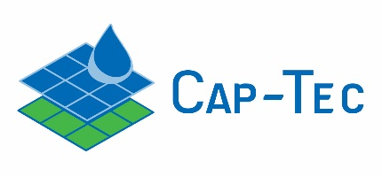
A special programme on capacity development in the use of new technologies for improved water management and productivity (Cap-Tec) will address capacity needs to maximise opportunities offered by new technologies for sustainable management and enhanced access to basic services, contributing to improved livelihoods, poverty alleviation, and environmental sustainability. The objective of Cap-Tec is to develop individual and institutional capacities for the incorporation and application of technological innovations, as intrinsic inputs for improved water management and productivity. Through Cap-Tec, collaborative and knowledge transfer links will be established between technology innovators, capacity development organizations, and stakeholder groups, including policy and decision makers, and river basin organisations, at the level of water management and use.

The Post-2015 development Agenda

The global agenda intends, between now and 2030, to end poverty and hunger once and for all; to combat inequalities; to ensure the lasting protection of the planet and its resources; and to create conditions for sustainable, inclusive and sustained economic growth and shared prosperity. The new development agenda is a plan of action for people, planet and prosperity which also seeks to strengthen universal peace in larger freedom. All countries, in collaborative partnerships will implement the agenda. The agenda declare the sustainable development goals and targets, means of implementation with global partnership, and means of follow-up and review.

Cap-Net UNDP contribution to the new development Agenda

In 2016-2020 Cap-Net’s mission is to expand and extend its capacity development in sustainable water management. Cap-Net UNDP’s strategic direction is themed “Water Knowledge for All: Empowering Individuals, Enabling Environments”. It focuses on sustainable water management concepts and principles, advances in information technology and innovation addressing implementation and monitoring processes. The vision and mission of Cap-Net is fully aligned with the overarching UNDP Strategic Plan (2014-2017), which take the human development approach as its conceptual foundation, and in particular emphasising support to capacity development leading to enhanced national and local capacities for human development.

Cap-Net Vision: Sustainable management and development of water resources and improved access to basic water supply and sanitation services benefiting the poor and contributing to improvement of livelihoods, environmental sustainability and reduced vulnerability to climate change taking into cognisance human rights, gender, diplomacy, leadership, transparency, accountability and integrity.

Sustainable Development Goals

Goal 1. End poverty in all its forms everywhere
Goal 2. End hunger, achieve food security and improved nutrition and promote sustainable agriculture
Goal 3. Ensure healthy lives and promote well-being for all at all ages
Goal 4. Ensure inclusive and equitable quality education and promote lifelong learning opportunities for all
Goal 5. Achieve gender equality and empower all women and girls
Goal 6. Ensure availability and sustainable management of water and sanitation for all
Goal 7. Ensure access to affordable, reliable, sustainable and modern energy for all
Goal 8. Promote sustained, inclusive and sustainable economic growth, full and productive employment and decent work for all
Goal 9. Build resilient infrastructure, promote inclusive and sustainable industrialization and foster innovation
Goal 10. Reduce inequality within and among countries
Goal 11. Make cities and human settlements inclusive, safe, resilient and sustainable
Goal 12. Ensure sustainable consumption and production patterns
Goal 13. Take urgent action to combat climate change and its impacts*
Goal 14. Conserve and sustainably use the oceans, seas and marine resources for sustainable development
Goal 15. Protect, restore and promote sustainable use of terrestrial ecosystems, sustainably manage forests, combat desertification, and halt and reverse land degradation and halt biodiversity loss
Goal 16. Promote peaceful and inclusive societies for sustainable development, provide access to justice for all and build effective, accountable and inclusive institutions at all levels
Goal 17. Strengthen the means of implementation and revitalize the global partnership for sustainable development
* Acknowledging that the United Nations Framework Convention on Climate Change is the primary international, intergovernmental forum for negotiating the global response to climate change
The strategic direction is further vertically aligned within the Water and Ocean Governance Programme (WOGP) for 2014-2017 of UNDP which envisages a world in which management, development and use of water and ocean resources is sustained and where there is accelerated effort towards ensuring universal access to safe household water supply and improved sanitation.

The identified WOGP signature programmes guiding Cap-Net thematic areas include:
- Climate resilient integrated water resource and coastal management
- Climate resilient access to water supply and sanitation
- Protection of trans-boundary surface and groundwater in a changing climate
- Sustainable management of oceans in a changing climate
- Cross cutting areas – innovative capacity development, knowledge management, gender, human rights based approaches, and intergity

Cap-Net UNDP addresses these signature programmes with limited focus on ocean resources but looking at sustainable coastal zone management as a new thematic area.

Guided by this vision and mission Cap-Net has identified 3 strategic goals for 2016-2020.
- Capacity Development: To develop capacity of institutions and individuals to manage, and use water and coastal zone resources sustainably, and to adapt to increasing climate variability within a context that addresses, human rights, gender, diplomacy, leadership and integrity.
- Strengthening partnerships. To improve water management practices by:
- using effective networks of capacity developers to impact on the ground, and
- developing partnerships with international agencies and private sector organisations to improve their outreach and collaboration on capacity developing.
- Knowledge management. To develop and implement knowledge management systems in response (innovative capacity development taking advantage of advances in IT), that ensure access to the best of international and local knowledge for all, measuring the effectiveness of capacity development services, and reviewing indicators and monitoring systems.

In addition, Cap-Net monitors its capacity development outcomes and impacts, and focuses on enhanced impacts through demand based capacity development. To this end Cap-Net has developed – and continually updates – tools for monitoring, evaluation and learning abbreviated as MELP.

Table 1: Cap-Net strategic themes and relevance for implementation of SDGs

Cap-Net thematic areas | Available and planned knowledge products and resources | Relevance for implementation of SDGs
1. Climate resilient integrated water resource and coastal management (Target 6.4 and 6.5) | Coastal zone management | Various materials under IWRM recognize and present the social, legal and policy reforms, economic instruments required to sustainably manage the scarce water resource. Cap-Net continues to update training materials and deliver knowledge under these themes to broaden the understanding of climate resilient water management, to manage, prepare and implement resilience plans for climate change and associated hydro-climatic disasters. Water management is key to sustainable development; the broader IWRM theme and delivery of knowledge under these themes envisaged a greater impact on achieving several SDG targets related to water, improved agricultural productivity, eradicate poverty, and conservation of coastal zones, ecosystems, and environment. Cap-Net also makes the provisions for enhancing knowledge on technology in developing countries providing equal opportunities to access and gain knowledge through the Virtual campus and Cap-Tec signature programmes.
 | Conflict resolution and negotiation skills for IWRM
 | Drought risk reduction in IWRM
 | Earth observation tools for IWRM
 | Economics in sustainable water management
 | Hydro-climatic disasters in water resources management
 | Improving productivity in agriculture
 | Integrated urban flood management/ Integrated flood management
 | Integrated urban water management
 | IWRM as a tool for adaptation to climate change
 | IWRM for river basin organisations
 | IWRM plans and IWRM tutorial
 | Streams of law
2. Climate resilient access to water supply and sanitation (Target 6.1, 6.2 and 6.4) | Sustainable sanitation and water management (SSWM) toolbox | Capacity development and knowledge products under water supply and sanitation contribute to achieve the targets on sustainable water supply and sanitation. Cap-Net training under SSWM considers water use and waste as a closed system as one impacts the other. Valuing and understanding the systems in sustainability point of view would remarkably improve the state of water and eco-systems. Developing the capacity to implement water safety plans also play a notable role in forest reserves and environmental conservation.
 | Water demand management
 | Water safety plans
3. Protection of transboundary surface and ground waters in a changing climate (Target 6.5) | Groundwater management in IWRM | Sustainable use and management of surface and ground water resources are vital in achieving the SDGs related to water, environment and climate change. The resource and capacity delivery on protecting water resources is of utmost importance to achieve sustainability.
 | Eco systems services and functions in IWRM
 | Managing water pollution within an IWRM approach
4. Crosscutting areas which address water governance across the thematic priority areas (Target 6.4 and 6.5) | Water integrity | Water governance is usually the bottleneck for reaching development targets. Cap-Net interventions address inequality, corruption, and human rights in water management through knowledge sharing and capacity development
 | Human rights based approach in IWRM
 | Working with indigenous people in IWRM
 | Why gender matters in IWRM: a tutorial for water managers
 | Water diplomacy and leadership
5. Innovative learning and educational programmes (Target 6a and 6b and Goal 17) | Cap-Tec | Cap-Tec focuses on capacity development in the use of new technologies for improved water management and productivity. Cap-Net virtual campus uses and adapt all relevant training materials for virtual training courses. School education programmes are also developed and delivered
 | Virtual campus
6. Strengthening partnerships and networking (Target 6a and 6b and Goal 17) | Network management tools (NMT) | NMT provides the knowledge for networking and partnership management.

Means of implementation in achieving SDGs

Cap-Net UNDP is poised to deliver on SDG commitments through its wide partnerships and affiliated networks that are dedicated to capacity development for sustainable water management. Many of the targets of SDGs are closely linked to water resources management as water remains a key resource that naturally govern food, energy, and environment. Basic principles of IWRM provide the drive for partnerships among institutions and all stakeholders including scientific and academic communities, governments and parliamentarians, business and private sector, civil society and all parties in the position to provide a vital contribution in achieving the development targets. Implementing all forms of resource management, effective utilization of water, land and related resources will ultimately impact in combatting hunger, healthy living and resilient to disasters. Strengthening national, regional and inter-regional alliances is required not only in realizing Goal 6, but for many other development goal targets. Cap-Net UNDP capacity development approach reflects the essence of SDG 17 i.e. use of national, regional and global partnerships for developing a knowledge base, and effective capacity development.

Cap-Net has comparative advantages to be a leading international network in realizing SDGs related to water. The strength of Cap-Net UNDP lies in its extensive outreach to capacity development institutions and its client’s base, its broad and diverse thematic and international partners, with 13 years’ experience in capacity development in sustainable water management. Cap-Net’s global network reaches the poorest and most neglected countries and connects them to state-of-the-art knowledge resources, training materials, South-South and North-South and inter-Regional collaboration. Cap-Net UNDP strategic direction is fully aligned with the means of implementation of the global development agenda, SDG 17, target 17.9 and SDG 6a and 6b declared as below;
SDG 17, Target 17.9: “Enhance international support for implementing effective and targeted capacity-building in developing countries to support national plans to implement all the sustainable development goals, including through North-South, South-South and triangular cooperation”.
SDG 6, Target 6.a: “By 2030, expand international cooperation and capacity-building support to developing countries in water- and sanitation-related activities and programmes, including water harvesting, desalination, water efficiency, wastewater treatment, recycling and reuse technologies”.
SDG 6, Target 6.b: “Support and strengthen the participation of local communities in improving water and sanitation management”.

Moving forward for “Water Knowledge for All: Empowering Individuals, Enabling Environments” during the strategic period 2016-2020, and beyond, Cap-Net will further strengthen the partnership with networks in developing countries to make knowledge on water management readily available, alongside improved accessibility to upscale and enhance outreach. By working with networks, Cap-Net responds to the demand on the ground and also provides local ownership for capacity development ensuring stakeholder participation at all levels in development planning as stated in the SDG 17. Cap-Net expects to further reinforce SDG targets into its work plan, and strengthen national partnerships Cap-Net partner networks in each country and expand the global network further by reinforcing south-south cooperation. This will lead to effective knowledge transfer and bridging individual knowledge development and institutional development which are closely bound approaches of Cap-Net, and will lead to a better impact and contributing to ending poverty in all its forms everywhere (SDG 1 mainly target 1.4 and 1.5). Cap-Net and partners will enhance financial leverage in capacity development in support of target 17.3.

Goal 6: Ensure availability and sustainable management of water and sanitation for all

Cap-Net in its 13 years of capacity development, has taken an enormous leap forward to develop and deliver knowledge on sustainable water management for all in collaboration with many organizations including GWP and UNEP-DHI. In addressing the sustainability of water and sanitation provision (Target 6.1 and 6.2), Cap-Net training materials have promoted the understanding of water and sanitation as an interlinked system and demoting the idea of end-of-pipe solutions. This helps all professionals and practitioners who are working in the sector to identify and resolve the problems of water supply and sanitation systems and view it from a sustainability lens. The consortium and other technical partners will take the lead for capacity development further by focusing on sustainability of water supply and sanitation systems, and reducing water pollution (Target 6.3). Cap-Net UNDP and partners have initiated a partnership programme called Cap-Tec. Cap-Tec is an integral signature programme aiming to bridge the technology and information gap in water resources management. Cap-Tec aims to respond to the capacity needs in applying new technologies for improved water productivity and management, responding to the demand of different target groups around the world. This addresses Target 6.4 which aims at increasing water use efficiency across all sectors, particularly in agriculture.

In accordance with Target 6.5 Cap-Net has already trained professionals in around 40 countries to implement IWRM at all levels with the knowledge of transboundary river basin management. Pollution management, ecosystem management and coastal zone management are included among the main priority thematic areas in 2016-2020 (Target 6.6).

Cap-Net’s Virtual Campus was launched in 2014 as an innovative signature programme to cope with increased demand for capacity development while reaching a wider audience in a cost effective manner. It delivers global training courses on various thematic areas related to climate change resilient water resources management and can be used as a workspace for networking and meetings. Cap-Net through its Virtual Campus can increase the outreach by using latest communication and technology innovations.

Not limited to Goal 6, but potentially contributing to all the projects and development on-going on climate change adaptation, Cap-Net will continue its international partnerships to combat the climate change and related disasters. Climate change resilience is mainstreamed in all thematic priority areas and is specially considered in designing training programmes.

Other related goals addressed

In enhancing north-south, south-south and triangular regional and international cooperation on access to science technology and innovation, especially related to water management (Goal 17: Targets 17.6, 17.16 and 17.18). The Cap-Tec programme seeks to address data and monitoring aspects by providing capacity on the use of new technologies for improved water management. The range of technologies include: remote sensing and GIS, use of drones, mobile phone technology among others. Cap-Net´s principles of demand responsiveness and partnership development to overcome capacity constraints places the global network in a catalytic role to address new developments and challenges, and respond with a knowledge management system conducive for information sharing and skills development. It is the conviction of Cap-Net that such programmes will develop a local pool of resources and professionals equipped with the technical knowledge required to face water management challenges in twenty-first century.

Goal 13 (take urgent action to combat climate change and its impacts) taken in combination with target 1.5 of goal 1 (to build the resilience of the poor and those who are in vulnerable situations and reduce their vulnerability to climate related extreme events and other economic social and environmental disasters) is central to Cap-Net activities, outputs and outcomes. The knowledge on resilience for hydro-climatic disasters needs to be adapted to regions and countries for planning and implementation of resilience actions. Cap-Net and networks will strengthen their partnerships further with the CBOs, NGOs, private and government bodies to reach marginalized and vulnerable communities in order to capacitate and equip them with the required knowledge. Cap-Net training materials are being extensively used by networks to deliver trainings on climate change adaptation and resilience. As demonstrated in the thematic priority areas of Cap-Net, climate resilience is fully integrated.

Cap-Net continues to streamline the gender dimension through educating women and girls with regard to water/sanitation use and management (Goal 5: Achieve gender equality and empower all women and girls). Together with the Gender and Water Alliance (GWA), Cap-Net has produced materials that countries can use in gender sensitization and mainstreaming gender in their water projects, towards ensuring more effective and efficient resources allocation and management. Capacity development works on gender and water management will be taken forward contributing to broaden the awareness on gender equality and women’s roles and responsibilities towards achieving sustainable water management.

Cap-Net intends to play a role in establishing a coherent framework for data, monitoring and accountability related to sustainable water management (Goal 17, Target 17.18 and 17.9).

SDG 17, Target 17.18: “By 2020, enhance capacity-building support to developing countries, including for least developed countries and small island developing States, to increase significantly the availability of high-quality, timely and reliable data disaggregated by income, gender, age, race, ethnicity, migratory status, disability, geographic location and other characteristics relevant in national contexts”.
SDG 17, Target 17.19: “By 2030, build on existing initiatives to develop measurements of progress on sustainable development that complement gross domestic product, and support statistical capacity-building in developing countries”.

To this end an initiative aimed at “Integrated Monitoring of Water and Sanitation Related SDG Targets”, referred to as the Global Expanded Monitoring Initiative, or GEMI has been launched in 2015 under the UN-Water umbrella. GEMI’s specific long term goal is to (i) establish and manage, by 2030, a coherent and unified monitoring framework for water and sanitation to inform the post-2015 period and (ii) contribute to country progress through well-informed decision-making on water, based on harmonized, comprehensive, timely and accurate information. The scope of GEMI is primarily limited to SDG 6, but it will also contribute indirectly to monitoring proposed related indicators in other SDGs.

Cap-Net foresees its role in engaging Member States and enhancing their capacity in collecting, reporting, and using sustainable water and sanitation related data. This will require capacity development at both individual and institutional levels through targeted technical support and capacity-building within countries.

SDGs and targets addressed by Cap-Net

Water is key in achieving poverty reduction, public health, food security, harmony in earth’s eco-systems, sustainable human settlements, Cap-Net UNDP strategic direction for 2016-2020 and beyond addresses many targets of the development agenda as summarised in Figure 1 (12 goals and 36 targets). The means of implementation under each target are deeply embedded in the Cap-Net UNDP programme. Cap-Net thematic areas and capacity development outputs and outcomes are aligned with the means of implementation (Goal 17: Strengthen the means of implementation and revitalize the global partnership for sustainable development) in the development agenda. Strengthening partnerships of Cap-Net global network forms the basis of contribution to achieve many development goals within the approach of integrated water resources management as illustrated in the Figure 1. Cap-Net intends to address the relevant SDGs and related Targets through its 3 strategic goals; namely 1. Capacity development for sustainable water management; 2. Strengthening partnerships; and 3. Knowledge management.

Financial envelope

The total envisaged resource envelope of contributed funding (excluding leveraged funding) for 2016-2020 is USD 17,500,000, based on an optimum budget of approximately USD 3,500,000 per annum shared across the strategic goals. The total leveraged co-funding (cash and in-kind) is estimated at USD 5,250,000 and that bringing the total virtual budget of Cap-Net for 2016-2020 to USD 22,750,000.

Figure 1: Cap-Net strategic directions and linkages for realizing SDGs
Goal 2: End hunger, achieve food security and improved nutrition and promote sustainable agriculture

Goal 3: Ensure healthy lives and well-being for all at all ages
Goal 5: Achieve gender equality and empower all women and girls
Goal 1: End poverty in all its forms everywhere

Goal 6: Ensure availability and sustainable management of water and sanitation for all
Goal 14: Conserve and sustainably use the oceans, seas and marine resources for sustainable development
1. Climate resilient integrated water resource and coastal management
2. Climate resilient access to water supply and sanitation
3. Protection of transboundary surface and ground waters in a changing climate
4. Cross-cutting areas which address, gender, human rights, integrity, diplomacy and leadership
5. Innovative learning and educational programmes
Goal 11: Make cities and human settlements inclusive, safe, resilient and sustainable
Goal 17: Strengthen the means of implementation and revitalize the global partnership for sustainable development everywhere
Sustainable development goals/targets
Cap-Net thematic areas
Goal 13: Take urgent action to combat climate change and its impacts

Goal 4: Ensure inclusive and equitable quality education and promote lifelong learning opportunities for all
Goal 15: Protect, restore and promote sustainable use of terrestrial ecosystems, sustainably manage forests, combat desertification, and halt and reverse land degradation and halt biodiversity loss
Goal 12: Ensure sustainable consumption and production patterns

Target 3.3, 3.4, 3.9
Target 1.4, 1.5
Target 2.3, 2.4
Target 4.7
Target 5.4, 5.5
Target 6.1 to 6.6
Target 12.2, 12.4
Target 11.1, 11.3, 11.6
Target 13.1 to 13.3
Target 14.2
Target 15.1, 15.2, 15.3, 15.8
Target 17.6, 17.7, 17.9, 17.16, 17.18

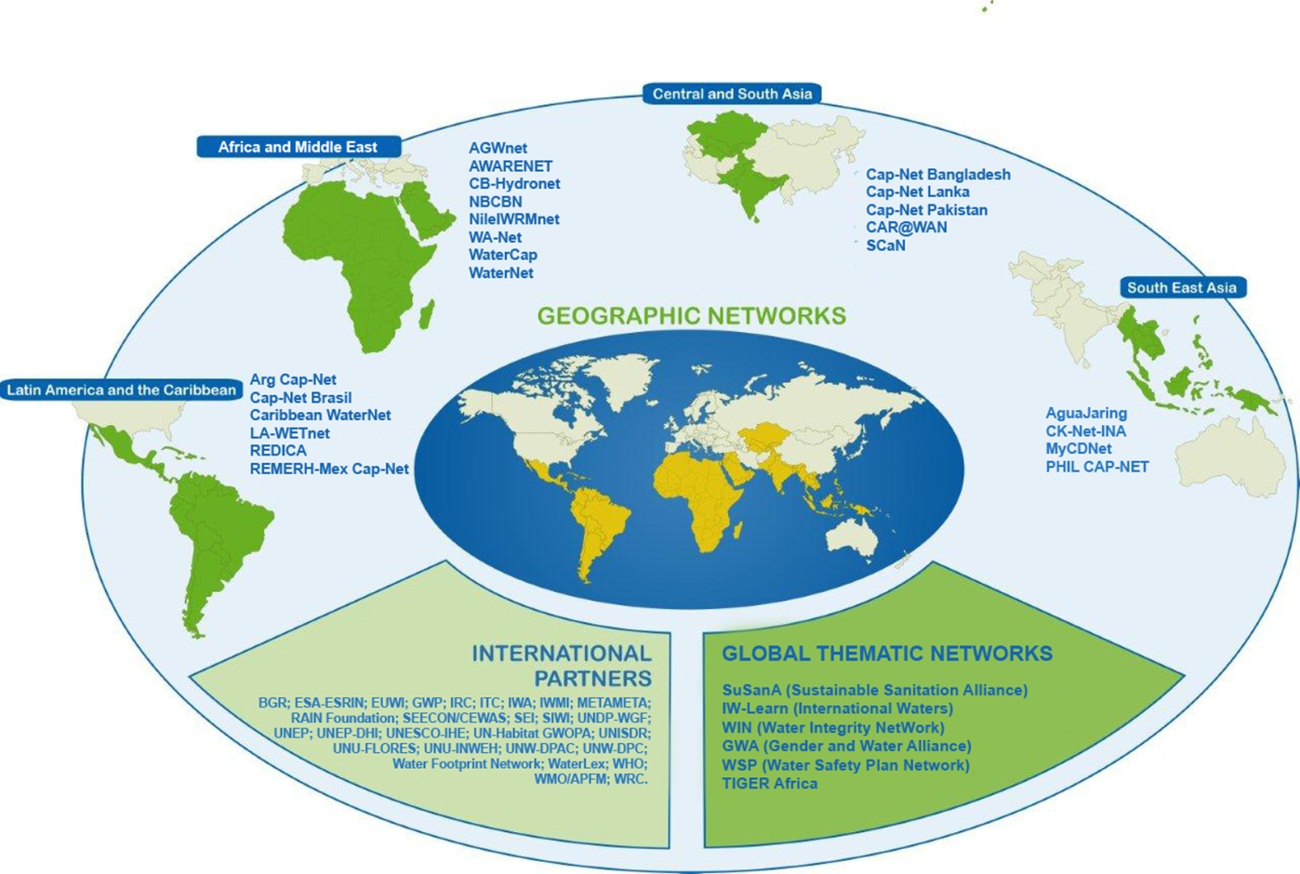

Cap-Net UNDP
International Network for Capacity Development
in Sustainable Water Management
Rua México 125,9° Andar
Centro, 20031-145
Rio de Janeiro RJ, Brasil
Email: info@cap-net.org
Website: www.cap-net.org
Follow us on: Facebook and LinkedIn

https://sustainabledevelopment.un.org/post2015/transformingourworld
http://www.un.org/pga/wp-content/uploads/sites/3/2015/08/120815_outcome-document-of-Summit-for-adoption-of-the-post-2015-development-agenda.pdf.
UNDP Strategic Plan, 2014-2017. Changing with the World: Helping countries to achieve the simultaneous eradication of poverty and significant reduction of inequalities and exclusion.
Water and Ocean Governance Programme (2014-2017). Contribution to realising the UNDP Strategic Plan 2014-2017.
Project document: GEMI is an inter-agency partnership comprising The United Nations Environment Programme (UNEP), the United Nations Human Settlements Programme (UN-HABITAT), The World Health Organization (WHO), the Food and Agriculture Organization of the United Nations (FAO), the United Nations Children’s Fund (UNICEF), the United Nations Educational, Scientific and Cultural Organization (UNESCO) and the World Meteorological Organization (WMO), operating under the UN-Water umbrella.

